Less Oxygen Better Bone Healing?
Bone formation and resorption, ensured by osteoblasts originating from mesenchymal stem cells (MSCs) and osteoclasts originating from haematopoietic stem/progenitor cells (HSCs/HPCs) respectively, maintain the skeletal system. This system is affected by several environmental factors, with hypoxia being of therapeutic interest as low oxygen improves HSC fate and survival [1] and induces the mobilization of MSCs into the peripheral blood from where they can induce bone repair [2, 3]. The group of Xavier Holy at the Institut de Recherche Biomédicale des Armées (IRBA), France, have now studied the effects of delayed hypoxic treatment in bone repair using a mouse model of femoral bone defect alongside hind-limb unloading, which mimics human plaster cast immobilization, generally applied to patients suffering from bone fractures [4].
The experimental design outlined in the adjoining figure describes the conditions utilised after bone-defect surgery (Day 0):
- NC (normoxia control) mice - normoxia until day 11 (sacrifice)
- NS (normoxia suspended) mice - hind-limb unloading for 7 days (days 4–11) under normoxia
- HC (hypoxia control) mice - hypoxia for 4 days before sacrifice
- HS (hypoxia suspended) mice - hypoxia for 4 days with hind-limb unloading
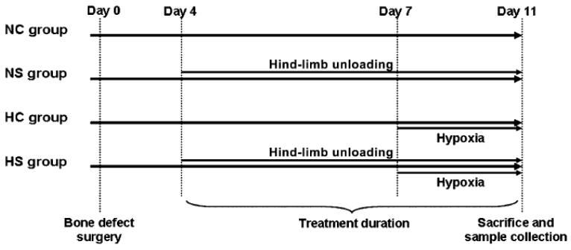
While hypoxia mediated an increase in both the efficiency of defect closing and filling of the cavity with newly mineralized bone, tail suspension (to induce hind-limb unloading) did not affect either. The researchers quantified bone formation and resorption parameters in the cavity of lesioned femurs, demonstrating that hypoxia induced osteoclast number (resorption) and reduced osteoblast number (formation) at the time of sacrifice. In all experimental cases, MSC number was higher in lesioned femurs than the contralateral femur, while hind-limb unloading, regardless of oxygen status, induced a global 29% decrease in MSCs. However, the researchers observed a 50% drop in contralateral femur myeloid-derived HPCs number during hypoxia suggesting a massive mobilization of HPCs from intact bone to the bloodstream, confirmed by a huge increase in myeloid-derived HPCs in the blood and spleen after 4 days of hypoxia. At the protein level, hypoxia led to a decrease in the level of Dkk1, a protein involved in the regulation of bone-metabolism balance, and an increase in MIP-1α, a pro-inflammatory cytokine promoting osteoclastogenesis. Interestingly, addition of a Dkk1 antibody delivery to bone fractures improved repair efficiency and biomechanical strength properties [3].
This altogether suggests that delayed hypoxic treatment improves bone healing through an enhancement on the natural bone-healing process, as evidenced by improved myeloid-derived HPC mobilization from undamaged bone, lack of MSC mobilization, increased osteoclast numbers in the bone, and from the proteomic analysis. This refutes other studies in which mice were faced with hypoxia for the entire recovery period, and not a delayed 4 day period before sacrifice [5, 6]. Furthermore, this study suggests that hind-limb unloading does not influence bone-healing efficiency in both normoxic and hypoxic mice, despite previous studies showing such an effect (e.g. [7]). Unfortunately, this hypoxic effect cannot be translated to humans at this moment and so further assessment of levels, time courses or pharmacological compounds that mimic hypoxia are required for the clinical application of such a strategy.
References
- Takubo K, Goda N, Yamada W, et al. Regulation of the HIF-1alpha level is essential for hematopoietic stem cells. Cell Stem Cell 2010;7:391-402.
- Rochefort GY, Delorme B, Lopez A, et al. Multipotential mesenchymal stem cells are mobilized into peripheral blood by hypoxia. Stem Cells 2006;24:2202-2208.
- Li X, Grisanti M, Fan W, et al. Dickkopf-1 regulates bone formation in young growing rodents and upon traumatic injury. J Bone Miner Res 2011;26:2610-2621.
- Durand M, Collombet JM, Frasca S, et al. In Vivo Hypobaric Hypoxia Performed During the Remodeling Process Accelerates Bone Healing in Mice. Stem Cells Transl Med 2014;
- Makley JT, Heiple KG, Chase SW, et al. The effect of reduced barometric pressure on fracture healing in rats. J Bone Joint Surg Am 1967;49:903-914.
- Lu C, Saless N, Wang X, et al. The role of oxygen during fracture healing. Bone 2013;52:220-229.
- Midura RJ, Su X, and Androjna C A simulated weightlessness state diminishes cortical bone healing responses. J Musculoskelet Neuronal Interact 2006;6:327-328.

